## Group 30: OS Assignment 2 Analysis

**Group Members:**

Khuzemah Hassan Qazi (24100092)

Qaboos Ali Khan (24100153)

As the number of allocations and free operations increase the system takes longer and longer. When plotted on the graph below, the time seems to grow exponentially when n=3, whereas the growth seems more linear for n=1 and n=2. If we had more data points, we could get a better representation of the rate of growth. We were unable to write this rate of growth in Big-O Notation due to there being two variables (n and m) and the complexity of Ackermann being unknown.

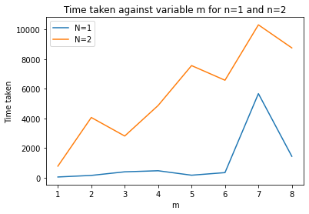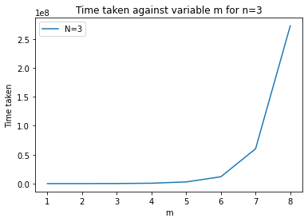

The system is using a linked list of all blocks allocated causing much delays. If the list only contained the free spaces, the space needed for the list would be lesser. If this change was made, the system would need to traverse a smaller list to find a free space for a new malloc. This would improve the time taken by reducing time taken by list traversals.

Usage of some sort of tree may also have been a more suitable data structure by taking lesser time to get to an empty leaf node.

Another point is that we kept the headers for the blocks in a space separate from the memory allocated to the buddy allocater. This may not be accurate to how headers may be stored in the blocks themselves. However, this should not affect performance too much.